Display Cheques for Payment Documents

S.NO. : 03- FI-Bank- 02

TRANSACTION CODE : FCH1

ACCESS PATH :SAP Easy Access Accounting Financial
Accounting Banks Environment
Check balance Display For Checks

We get “ Display Check Information” screen

Required fields

Paying Company Code : To be entered (Grow)
Check Details Viz, House bank, and Account ID fields to be entered

Then go to top of the screen

Press Check → List

We get “ Check Information- List ” screen

Required fields

Paying Company Code : To be entered (Grow)
Check Details Viz, House bank, and Account ID fields to be entered

Press execute Button/F8

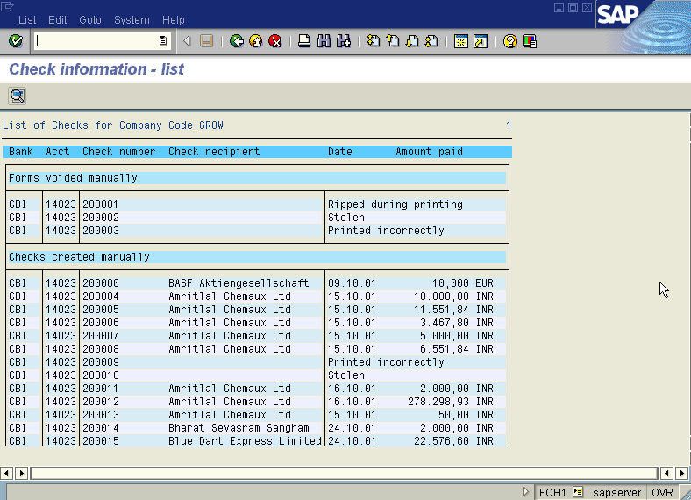
We get “ Check Information- List ” screen as under

